**Convert Currency to Words Documentation**

Technologies Used:

* ASP.NET MVC
* ASP.NET Web API
* JavaScript
* CSS
* Unity.WebAPI
* Using Moq for Unit Testing

Steps to Run the Solution:

1. Open the Solution file in Visual Studio 2015
2. Right click the Solution and Click Properties
3. Change Startup project to Multiple startup projects and select the web application, Services action as start like below screenshot.

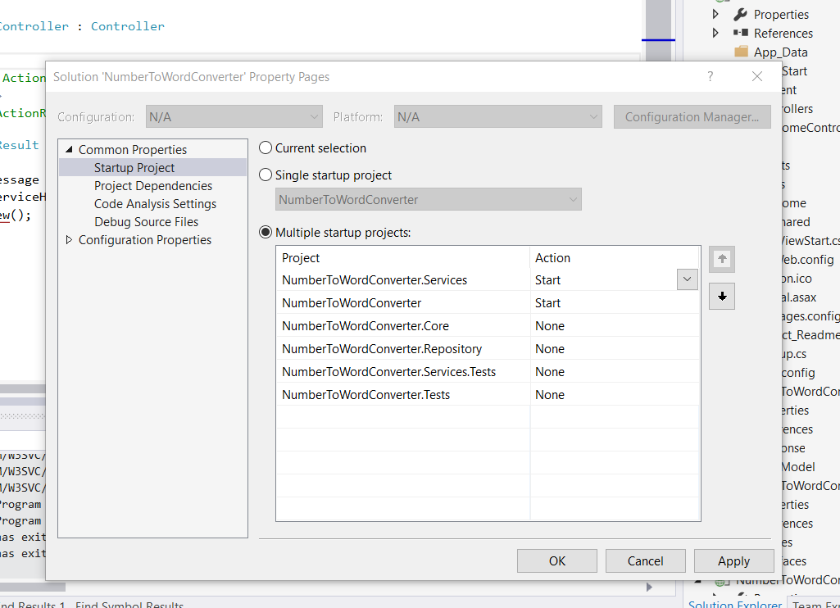

1. F5 to Run the Solution

**Technical Hints:**

I have created the Web API as Service and MVC are different projects. When you hit the F5 in Visual Studio, both applications will start.

In case you are facing the issue while converting the currency to words, Please update the ServiceHostUrl in web.config.

ServiceHostUrl Value is WebAPI Project Host URL.

<add key="ServiceHostUrl" value="http://localhost:38964/"/>

**Output Screenshots:**

